Termwork 4

Name: name

USN: 2GI20CSXXX

Date: 12/12/2022

**Terminal 1**

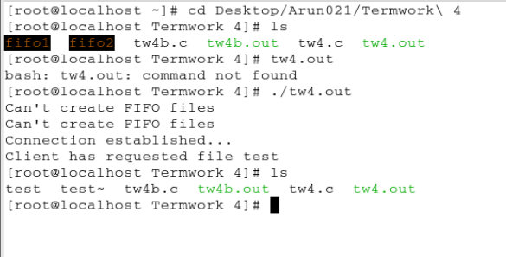

**Terminal 2**

